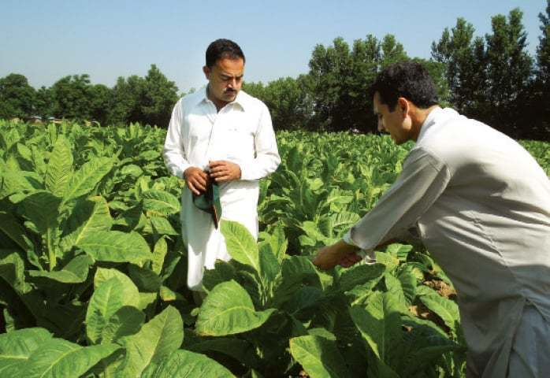

**ZULFIQAR WARRAICH**

**(34 years)**

**Farmer of Mangoes, Water Melon & Melon**

**Land Ownership: 60 acres**

**Basti Malook, Multan**

Zulfiqar Warraich, a foreign qualified landowner with specialization in micro biology, runs his fruit business based on state of the art technology and processes. His passion is to produce export quality fruits and introduce it to the world as ‘Grew in Pakistan’. He joined F2P value chain to provide Pakistani consumers, export quality fruit products at their doorsteps.

You can also reach Zulfiqar Warraich directly at whatsapp: 0345 – 8550743